1)INTRODUCTION
A) OVERVIEW
Fashion Haven is a private Limited company also registered under GST in Tamil Nadu. Fashion Haven is a retaillor of various lifestyle products in wholesale and retail, it has a wide range of customers (B2B&B2C) all over the state and it procures from various suppliers in the state. It operates at a GrossProfit margin of 50%.
B) PURPOSE
Fashion Haven, an online retail store, Leverages Zoho Books to manage their inventory and track sales. They can generate invoices and manage customer payment seamlessly. Zoho Books also enables them to reconcile bank transactions and generate financial reports, helping them make informed decisions about their business..

2) Problem Definition & Design Thinking
A) Empathy Map

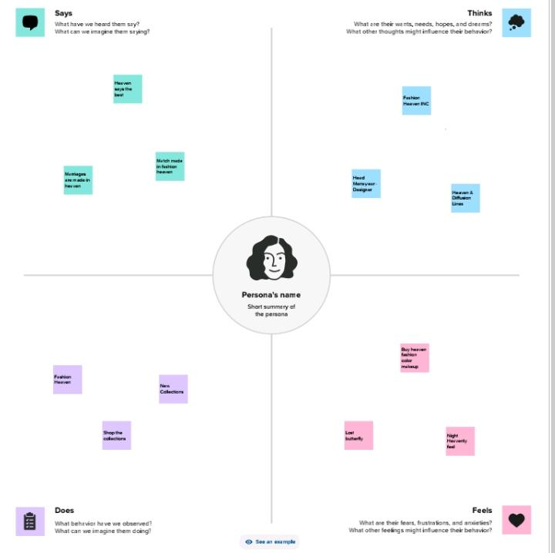
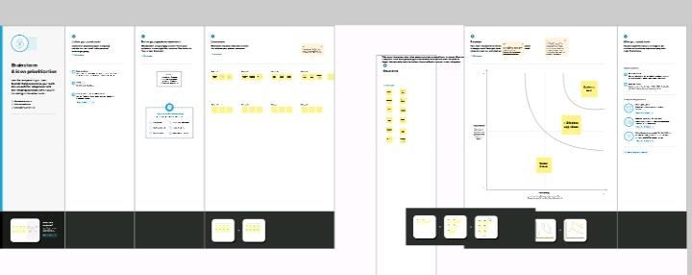
B) Ideation & Brainstorming Map

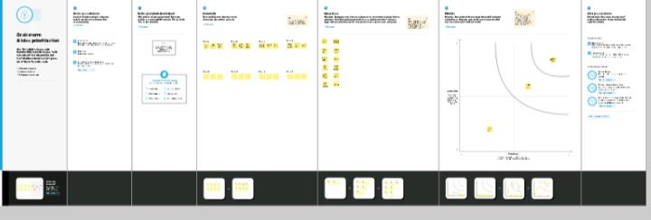

3) RESULT
A)PROFIT AND LOSS A/C

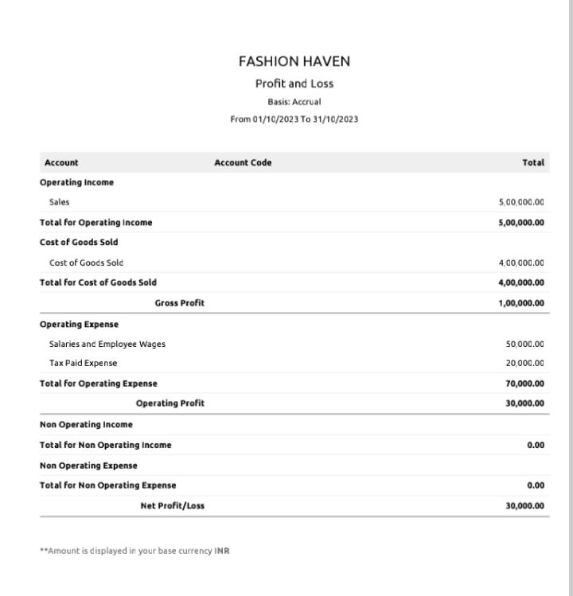

B) BALANCE SHEET

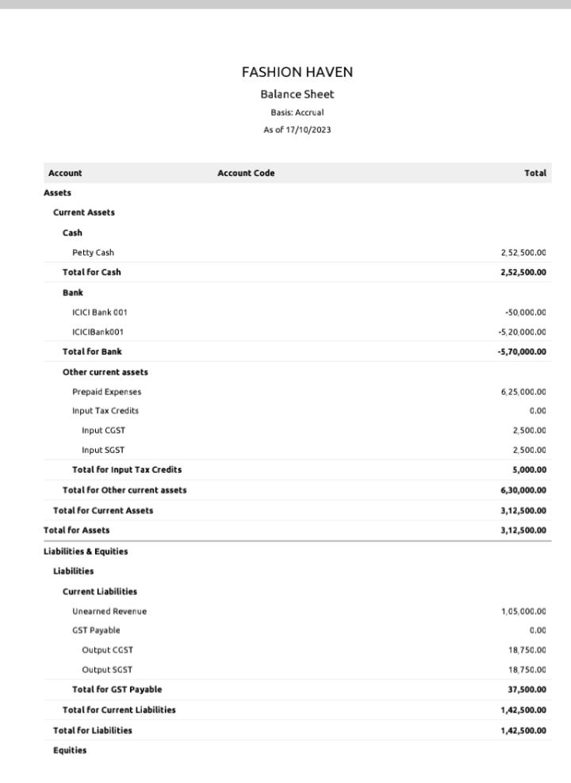

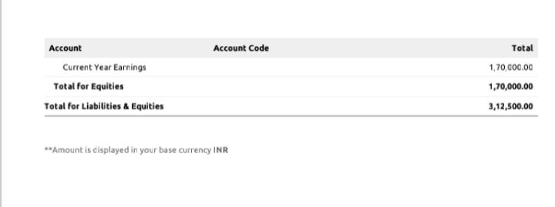

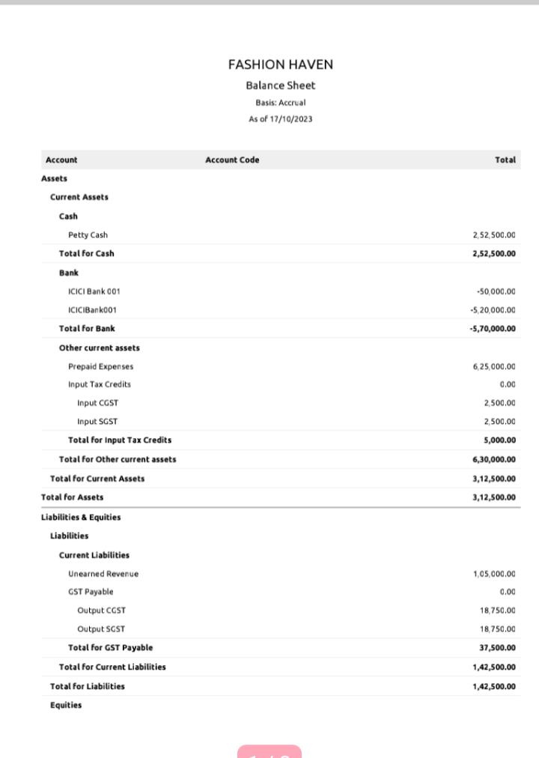
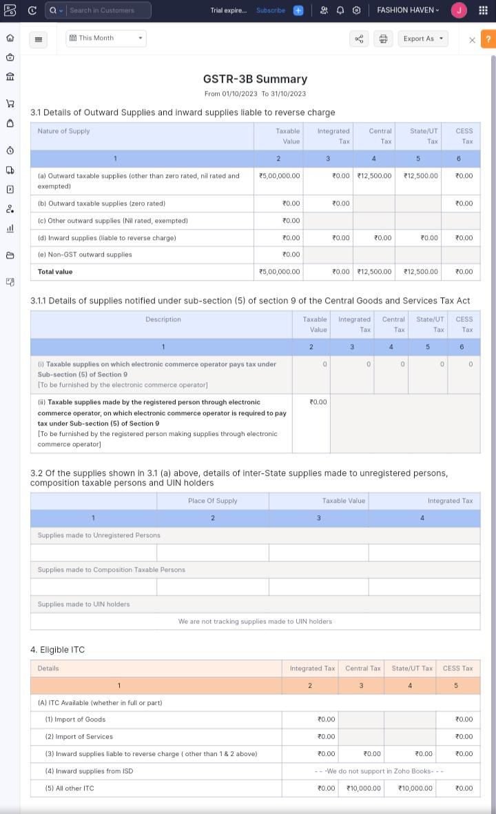
D) JOURNAL REPORT
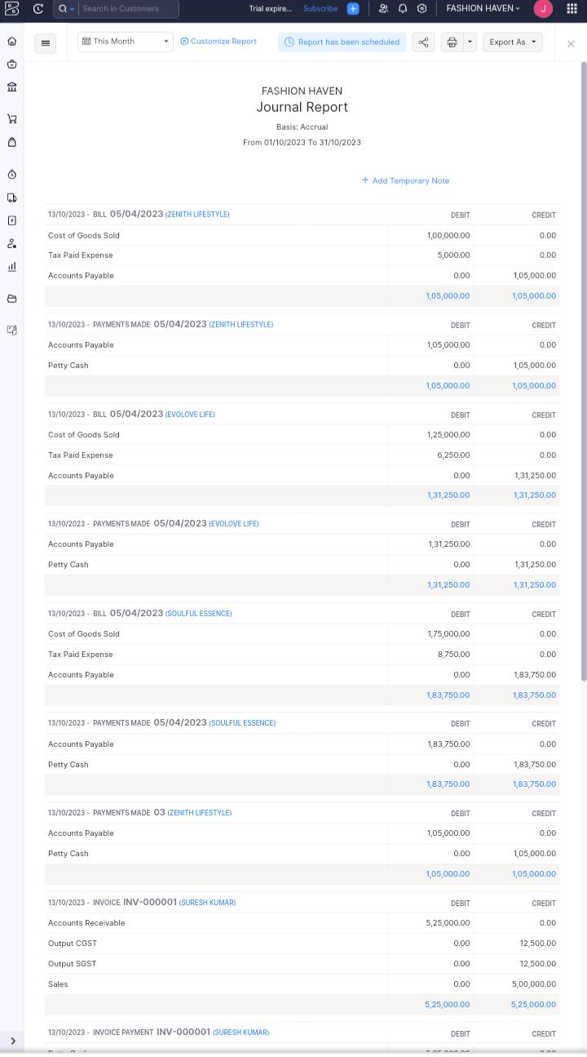
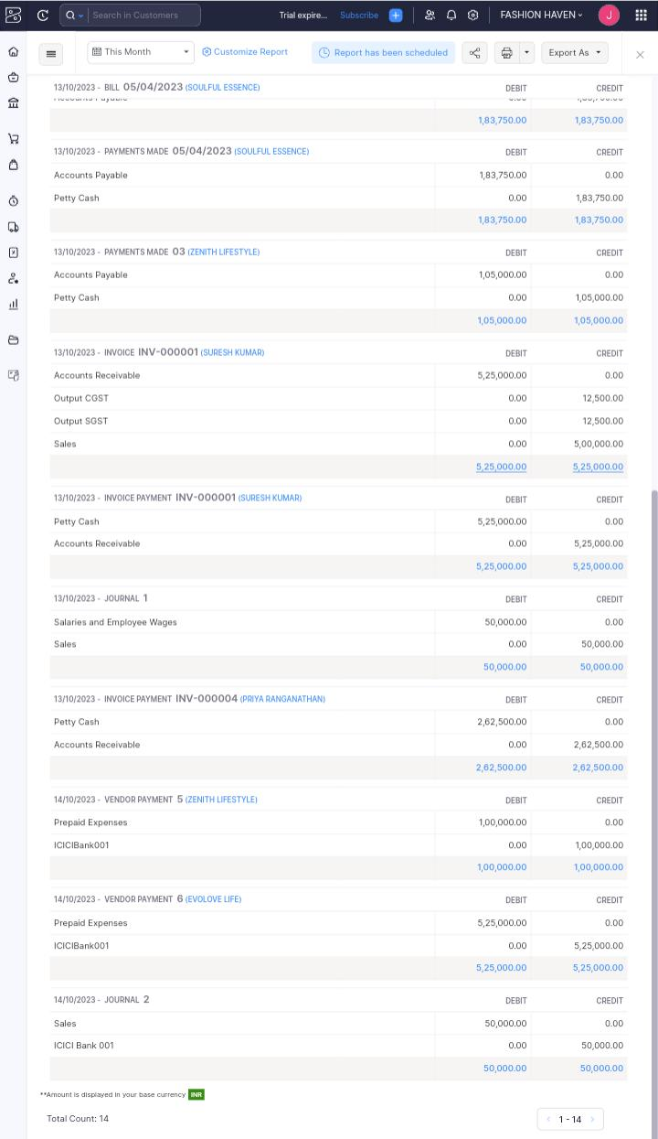
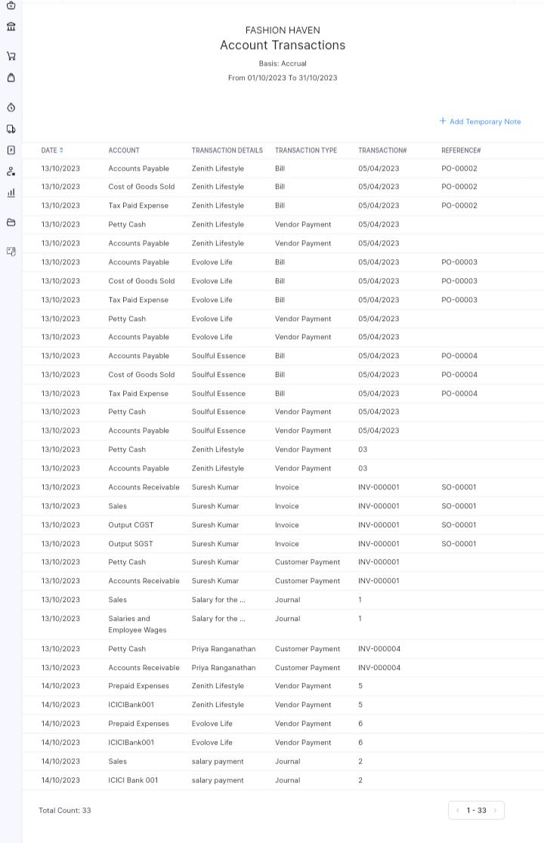
D) ACCOUNT RECEIVABLE AR AGING DETAILS
E) ACCOUNT PAYABLE AR AGING DETAILS
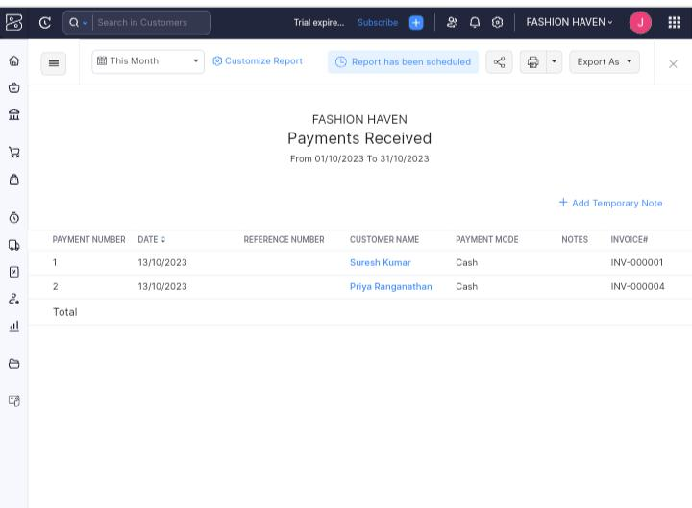

4) ADVANTAGE AND DISADVANTAGE
ADVANTAGES
- Invoicing and Billing
- Expense tracking
- Minimize Data Lost
- Report Generation
- Inventory Management

DISADVANTAGES
- Difficult to Modify Invoice
- Maximum of 10 Users
- Time Tracking must be tied to project
- Limited Bank syncing
- Difficult to Modify Bills

5)APPLICATION
The Zoho Books are applied in our business to record the sales and purchase to generate
invoice and bill and manages the customer payment and vendor Payment. It also maintain the expense and other transaction related to the business. And we can also maintain the cash book and bank accounts in this could based accounting software. It also gives all the financial report about the profit and lossA/C, Balancesheet,GSTReport, Account Receivable AR Again Details, Account Payable AR Aging Details and etc. This all the details can help to decision making for future business purposes
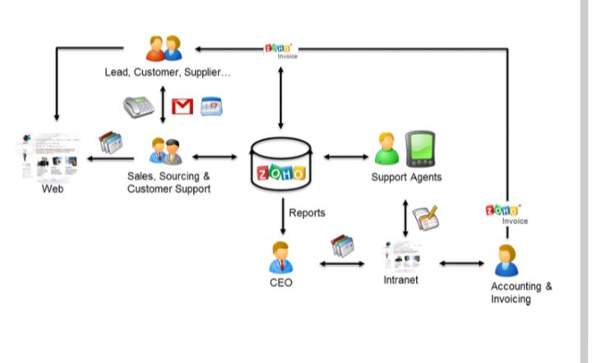
- CONCLUSION
This Zoho Books are Usefull to maintain, record,summarize and analysis accounting entries
Made in this could based software. We need any maintain the accounts.That the transaction are recorded while the entering in this software.Then we can add the journal and then we can get the profit and loss A/c, Balance sheet,GST Report and etc.We don’t need one software to enter bill and another software to maintain accounts.We can prepare the bill and maintain accounts in one software
- FUTURE SCOPE
- It best software to manitain accounts and for billing,
- so we need not tally.
- This will be used by most company to maintain accounts in their company.
- There is need not any accountant to record the transaction.
- Reduce the time to maintain accounts.

